**MANUAL STEPS TO TRANSFER THE PARTNER’S FEED**

**HPExportfeedsToPartners job** :

We are sending files to the following partners in HPExportfeedsToPartners job.

**Partner List for SFTP:** dummy,bluekai,spos,productAdvisor,hpemarketplace,kelkoo,google,affiliatewindow,flashtalking,exacttarget,exacttargetCrossSell,channeladvisor,microsoftbing,analytics

If we got the following error means, PFA for mail reference.



We need check the file on below path for the log:

**File name: HPExportFeedsToPartners.log.20180126.1321(sample log)**

**Path: /opt/apps/PDHDataLoad/logs/**

**Hostname: g1t4723c.austin.hpicorp.net**

Then search for ‘error in the log for to know that which partners file transfer has failed (Some keywords to grep in log are error, failed)

In the below screenshot you can find the error message,

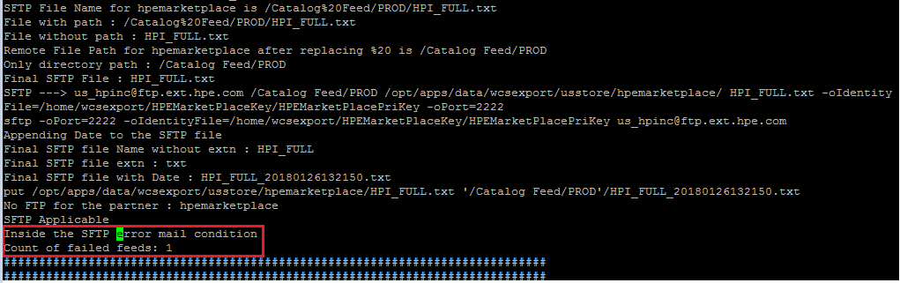

In the below screenshot, you can find the **file name , path, sftp connection port and its path** of the respective partner which has failed to transfer the feed.

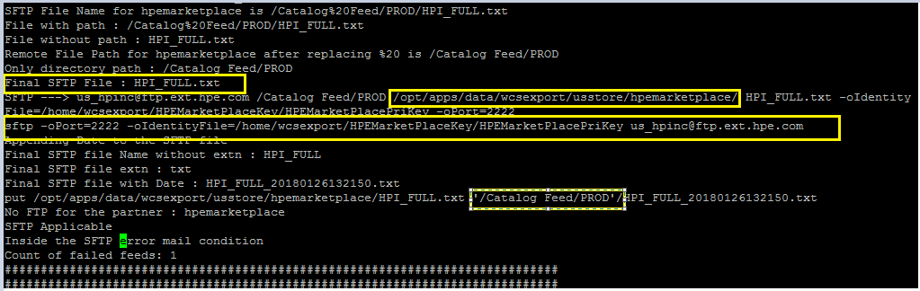

Once you got the details,

Connect as the wcsexport user in production job server:

**ssh** [**wcsexport@g1t4723c.austin.hpicorp.net**](mailto:wcsexport@g1t4723c.austin.hpicorp.net)

Go to the below path, (which we took from the log)

**cd /opt/apps/data/wcsexport/usstore/hpemarketplace/**

And check for the below file with the current date, (File name we can take it from the log)

**HPI_FULL.txt**

If the file has been found proceed with below steps, (if not please check with DLP team)

Connect to the partner by below sftp command, (which we took from the log) PFS below for reference,

**sftp -oPort=2222 -oIdentityFile=/home/wcsexport/HPEMarketPlaceKey/HPEMarketPlacePriKey** [**us_hpinc@ftp.ext.hpe.com**](mailto:us_hpinc@ftp.ext.hpe.com)

Go to the below partner’s path, (which we took from the log)

**cd Catalog\ Feed/PROD**

And enter below command,

**Put HPI_Full.txt** (to transfer the file)

Enter ‘ls –ltr’ to check the file is transferred with current day and timestamp, PFB screenshot.

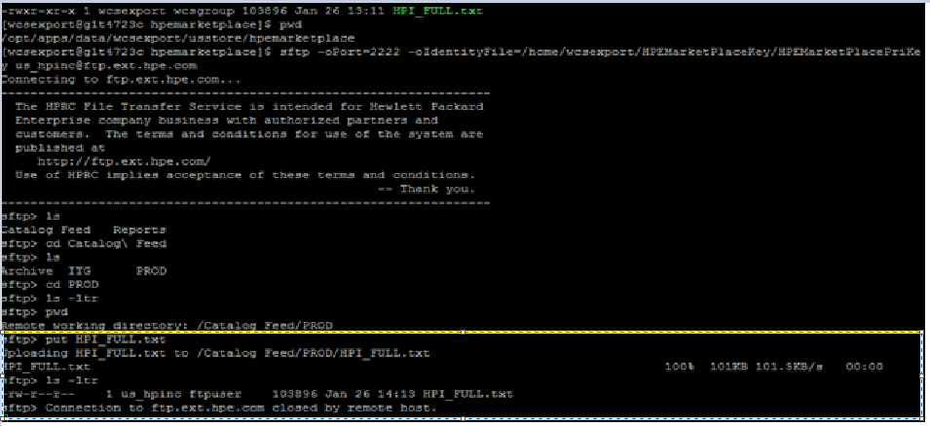

Here we saw the steps for the ‘hpemarketplace’ partner like this we have to follow the steps for the respective partners to transfer the feed if it is failed.